9/12/2023

Chakradhar Bhogapurapu

Database Schema

A database schema is a structure that represents logical storage of the data in database. It gives the information about relationships between the tables in database.

In database, the information is stored in well structured format.

Database schema have schema objects that include tables, fields, primary key, etc.

Schema do not have physically data itself. It gives information about the shape of data and relation between tables.

Types of Database Schema

* Physical : It says how the data is stored physically on storage system in the form of files.
* Logical : It specifies all the logical constraints that need to be applied to the stored data. Programmers, administration and the implementation of the data structure is hidden at this level.
* View : View level design of database is known as view schema. It describes about the end user interaction with the database system.

Creating Schema

“CREATE SCHEMA” creates a new schema with the name provided by the user.

Database Schema Designs

* Flat model : Used for small applications. It is a type of 2-D array where each column contains same type of data and elements within a row are related to each other.Database table with no relations.
* Hierarchical model : It is tree like structure. Tree structure contains root node and child nodes. Nodes have one-to-many relationship.
* Network model : It is represented as series of nodes. It allows many-to-many relationship. It is used for spatial calculations.
* Relational model : It is used for relational database, which stores data as relations of the table.
* Star schema : It is used to wor =k with large amount of data. It works on ‘Facts’ and ‘Dimensions’.
* Snowflake Schema : It is adaption of star schema. Snowflake’s dimension table can have their own dimensional tables.

Creating procedure

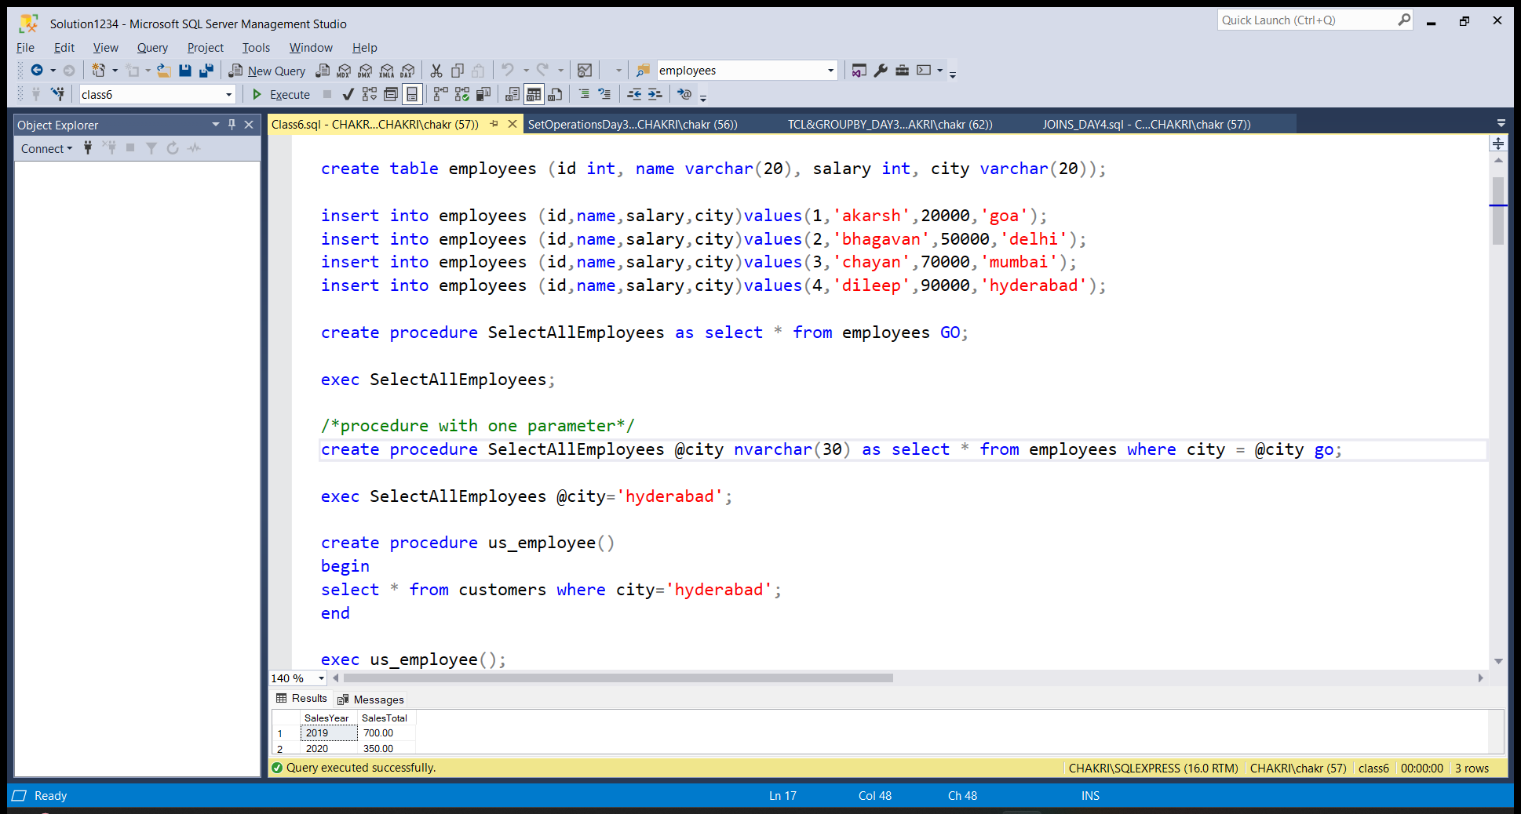

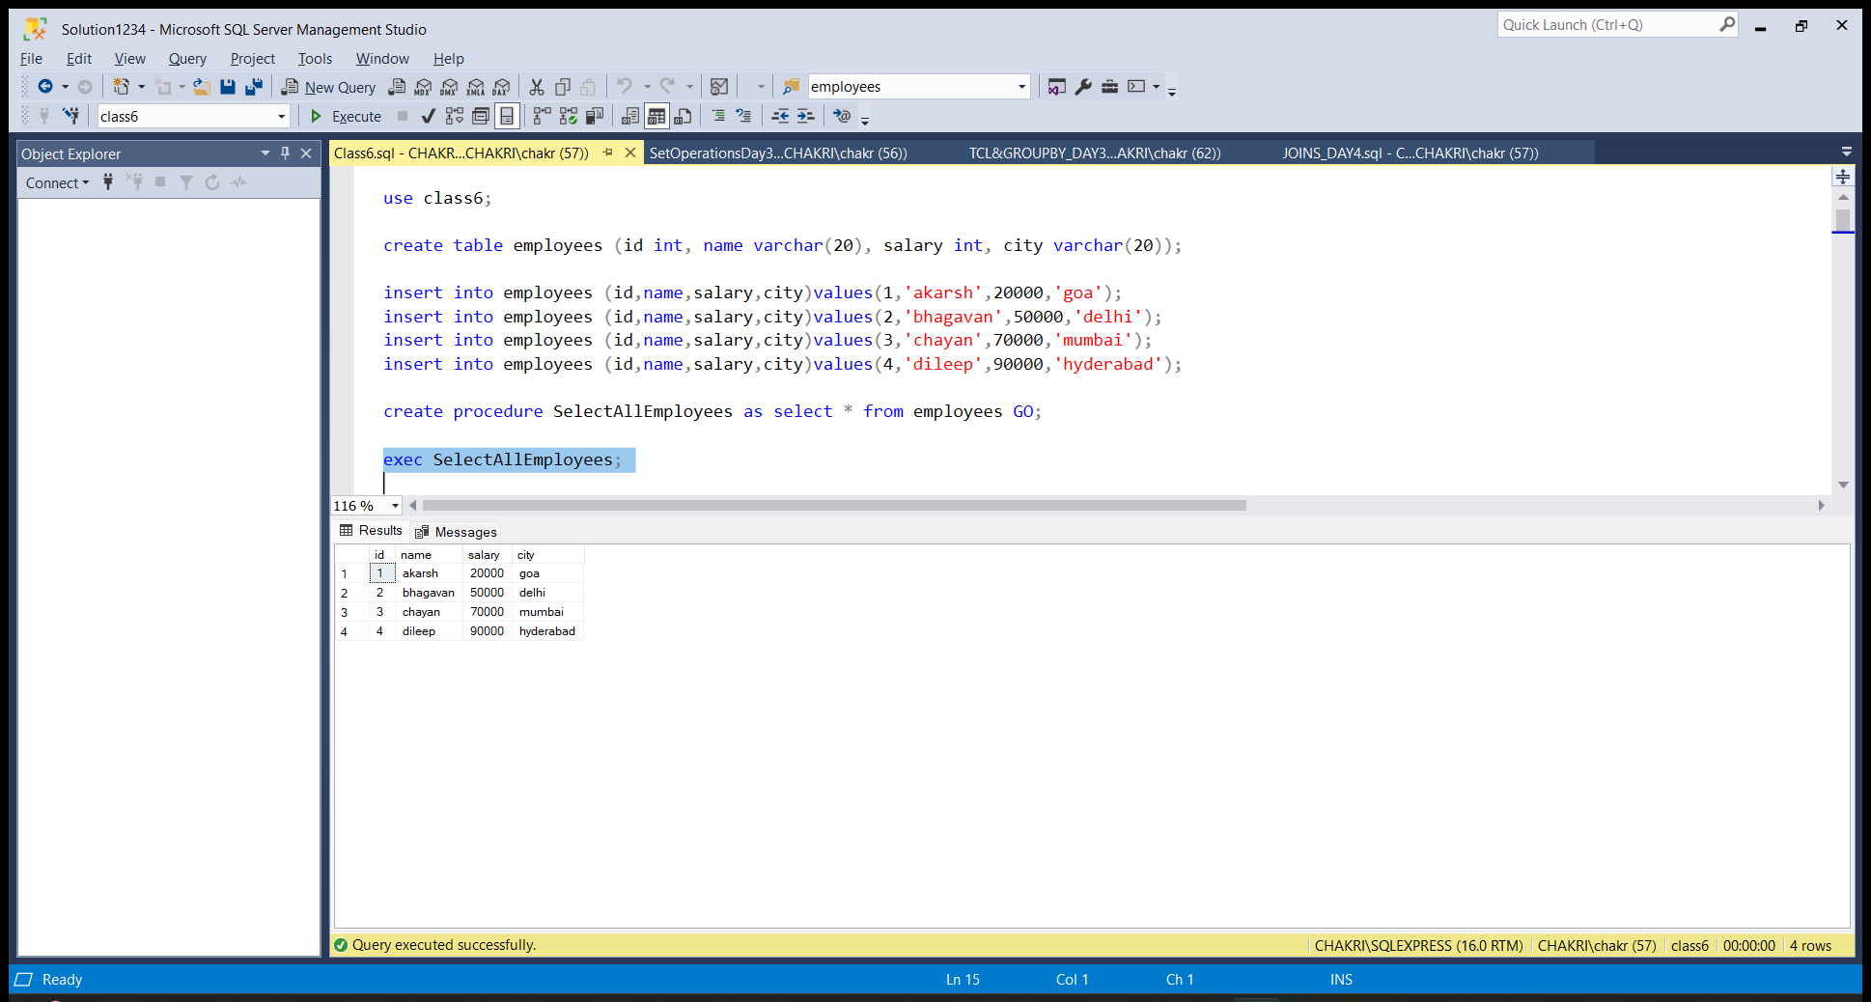

SQL Queries

ROLLUP()

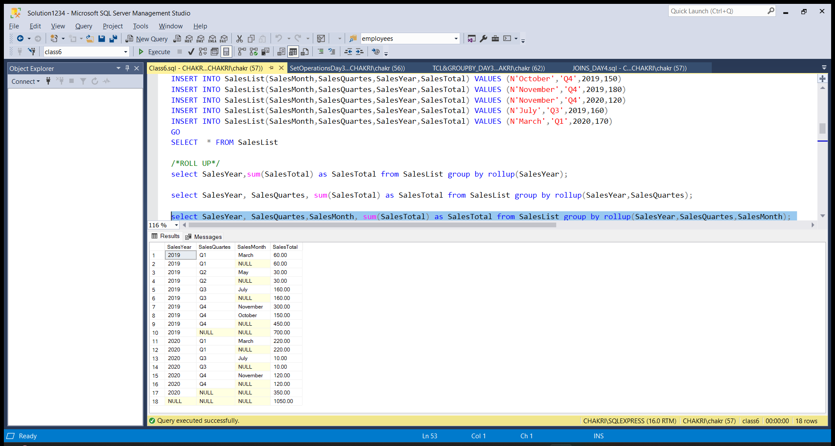

GROUPING()

